COCKTAILS
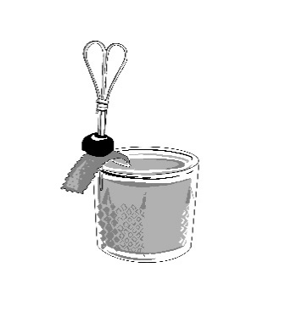 | SIGNATURE  ITALIAN OLD FASHIONED  House-infused vanilla & orange  bourbon, maraschino liqueur,  bitters, amarena cherry | 15 | 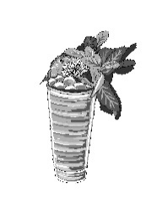 | SEASONAL  PARADISO  Blanco tequila, liquor 43,  pineapple, black lime, orgeat,  papaya | 15
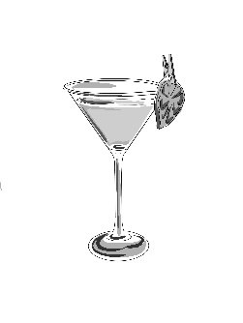 | LIMONCELLO MARTINI  Vodka, limoncello, lemon | 15 | 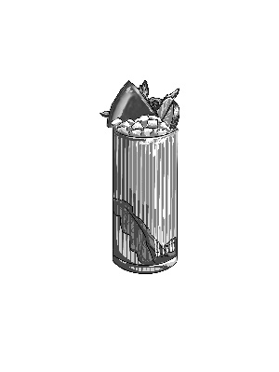 | PINK FLAMINGO  White rum, muddled watermelon,  lime, mint, soda | 15
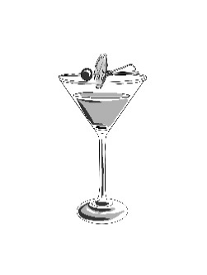 | CIAO COSMOPOLITAN  Vodka, orange liqueur, lime,  cranberry, amarena cherry | 15 | 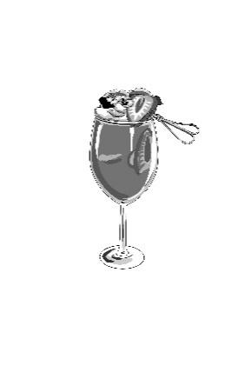 | LIMONATA SPRITZ  Vodka, lemon, strawberries,  prosecco | 15
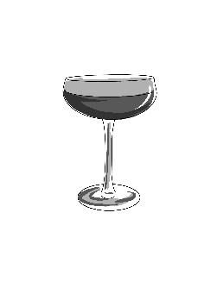 | ESPRESSO MARTINI  Chilled espresso, vodka, coffee  liqueur, Irish cream, vanilla bean | 15 | 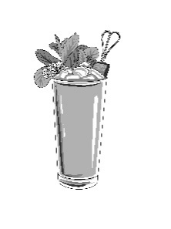 | RASPBERRY LIME RICKEY  Vodka, lime, raspberry,  guava paste, soda | 15
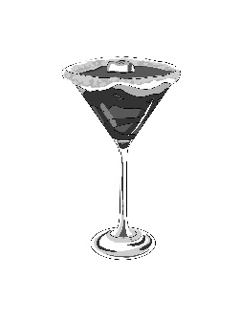 | TOASTED SMORES MARTINI  Coffee liqueur, toasted marshmallow,  honey whiskey, horchata | 15 | 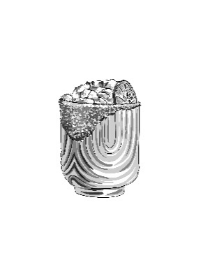 | MATCHA BETTAH  Coconut tequila, key lime, vanilla,  coconut milk, matcha, key lime rim | 15
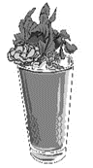 | POMEGRANATE MOJITO  Pomegranate, white rum, lime,  muddled mint, soda | 15 | 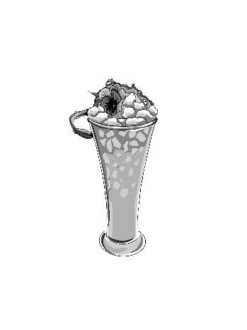 | LEONITUS  Empress 1908, Italicus, hibiscus,  pineapple, guava, lime | 15
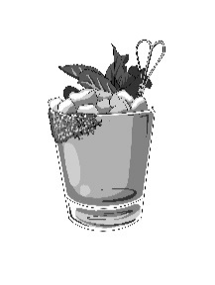 | GHOSTARE  House-infused jalapeno tequila, lime  passionfruit liqueur, tajin rim | 15 | 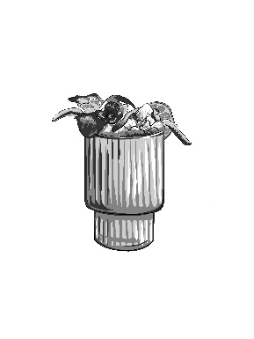 | SNEAKY TEAKY  Malibu strawberry, pineapple rum,  blood orange, pineapple, mango,  grenadine | 15
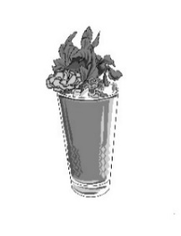 | MANGO DRAGON  Vodka, passionfruit liqueur, mango,  dragon fruit, mango popping bubbles,  lemon-lime | 15 | 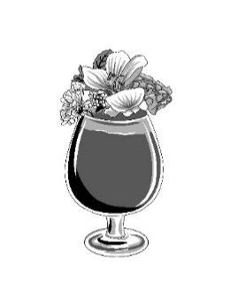 | OOOHH BAE  Malibu, coconut rum, ube milk,  lime, pineapple, mango | 16
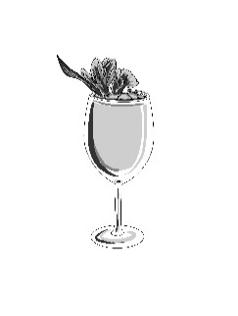 | SEASONAL SANGRIA  Glass / Pitcher  Red or White | 14/40 | 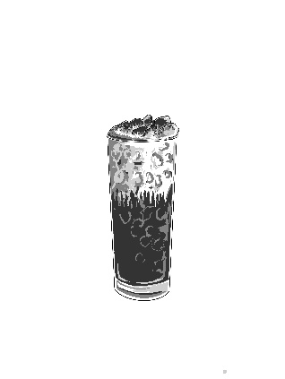 | TIRAMISU COOLATTA  Vanilla vodka, coffee liqueur, café latte, espresso, whipped cream,  cocoa, lady finger | 15

MOCKTAILS

LAVENDER LEMONADE  Lemonade, lavender, lemon | 9 | FIORE FRESCA  Pineapple, guava, lime, orgeat, soda | 9
POMEGRANATE CITRUS  Pomegranate, blood orange, lemon, soda | 9 | ORANGE CREAMSICLE  Blood orange, coconut, lime, soda | 9

